Вариант 8 – AA.csv

Разведочный анализ (EDA)
Динамика целевой переменной
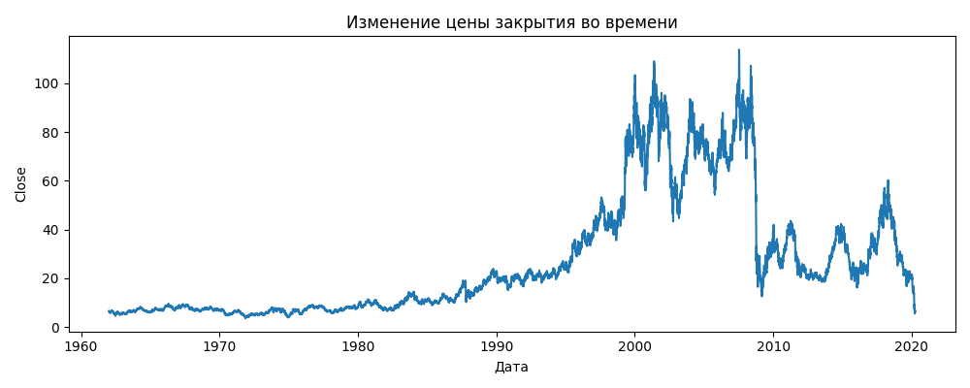Распределение целевой переменной
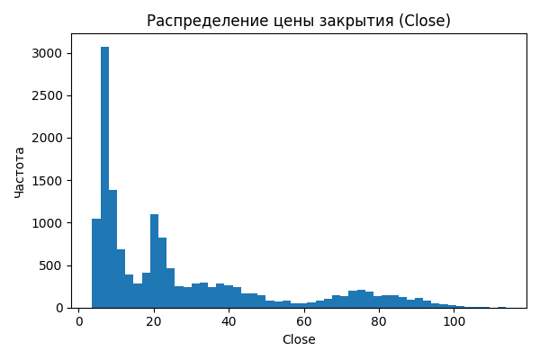3.3 Корреляционная матрица

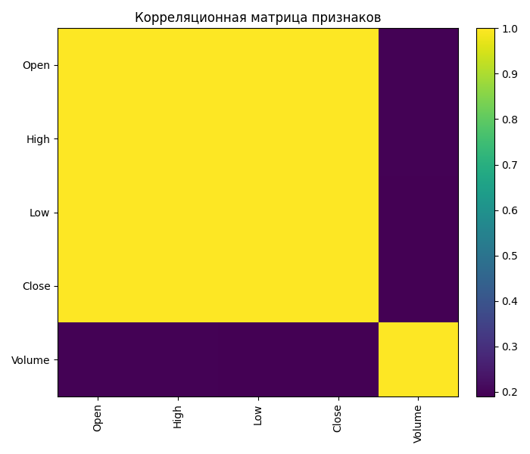

Методология
Модели: LinearRegression (со стандартизацией) и RandomForestRegressor; целевая переменная: Close; признаки: все числовые столбцы, кроме Close; кросс-валидация: TimeSeriesSplit; подбор гиперпараметров RF через GridSearchCV; метрики: RMSE, R².

Результаты моделей
Сводные метрики
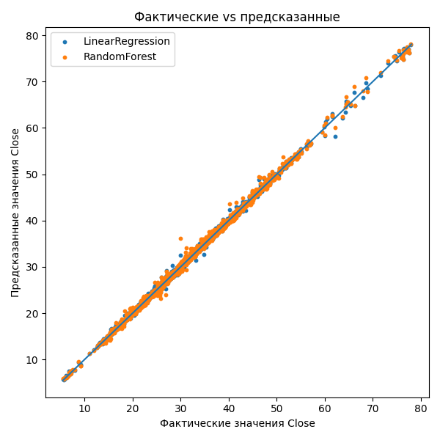
Факт vs предсказание (тест)
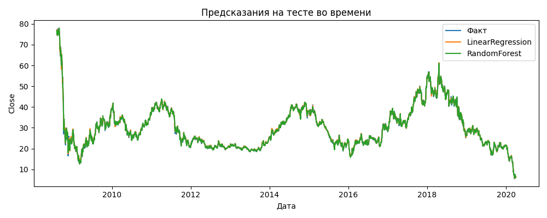
Динамика прогноза на тесте
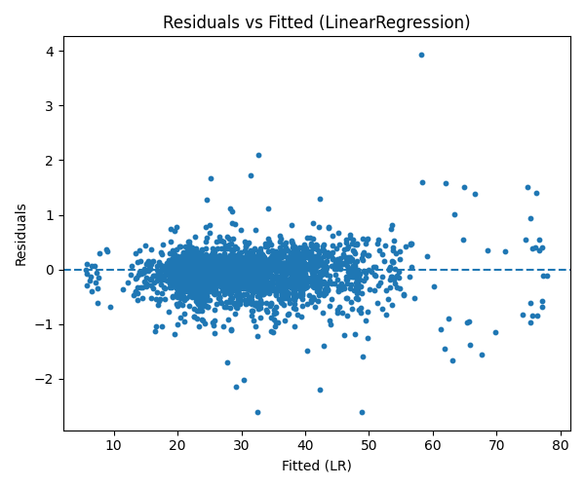

Диагностика ошибок (Residual Analysis)
Остатки vs Предсказания (LR и RF)
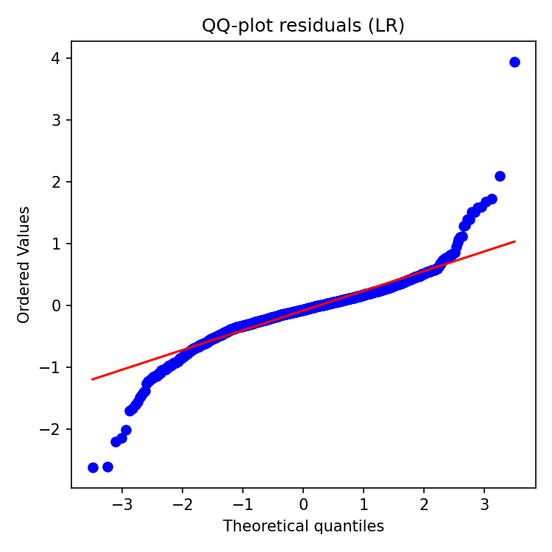
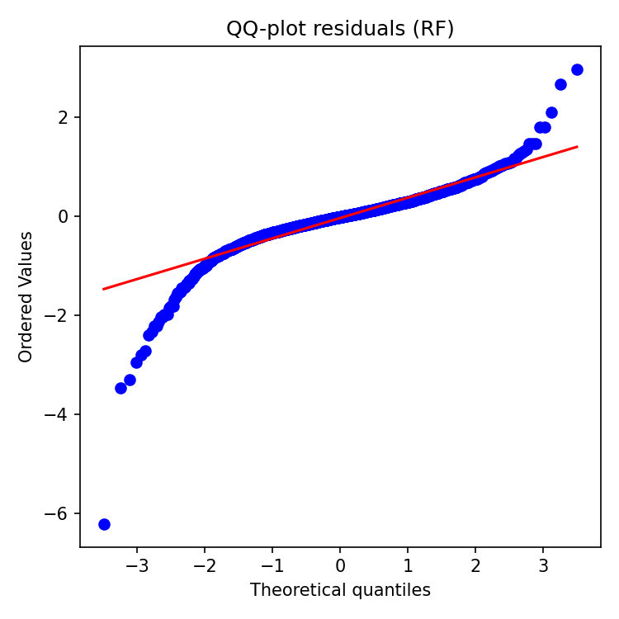
Распределение остатков
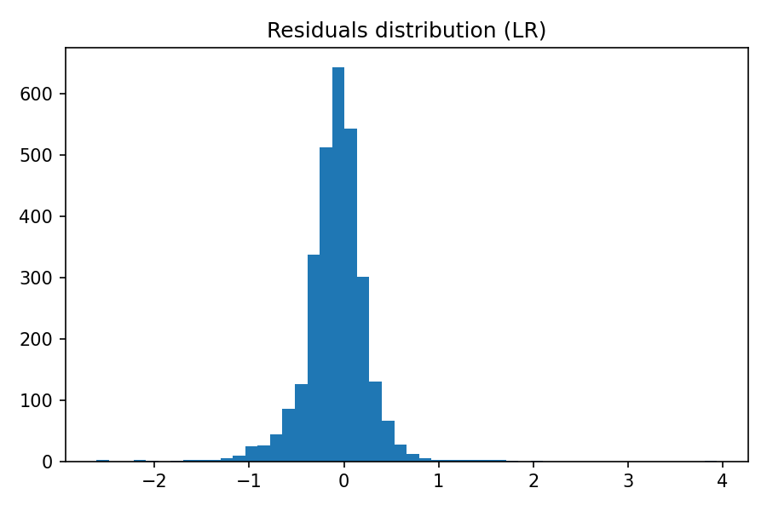
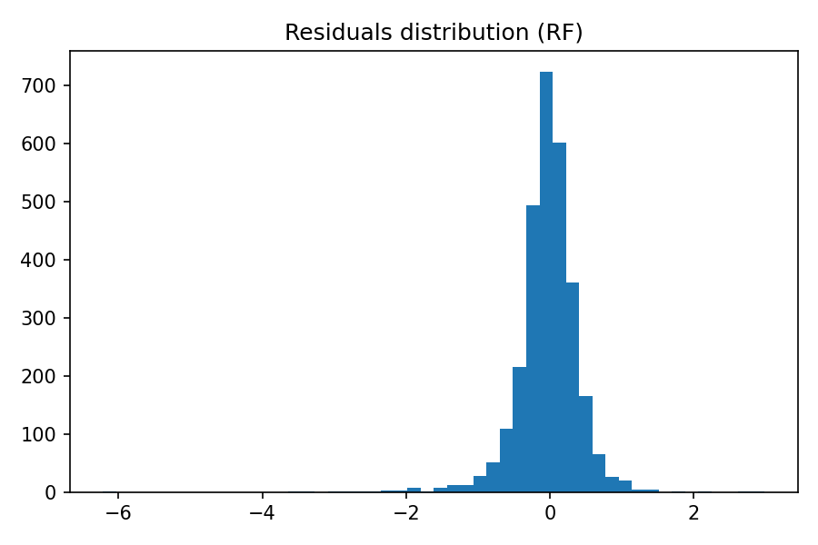

Интерпретация признаков
Важности признаков RandomForest
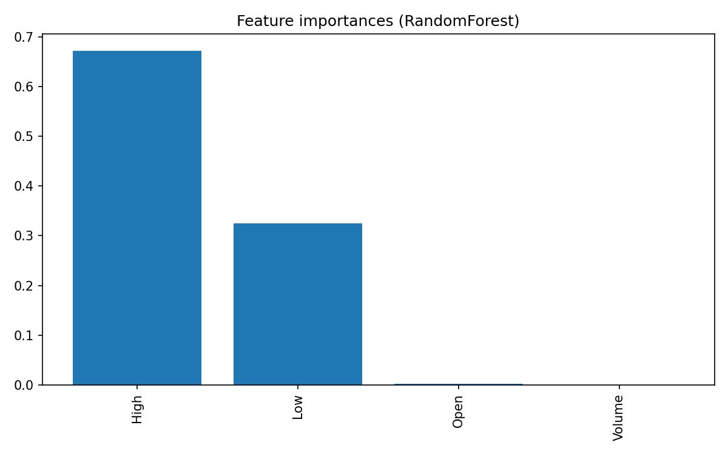
Scatter-matrix по топ-признакам

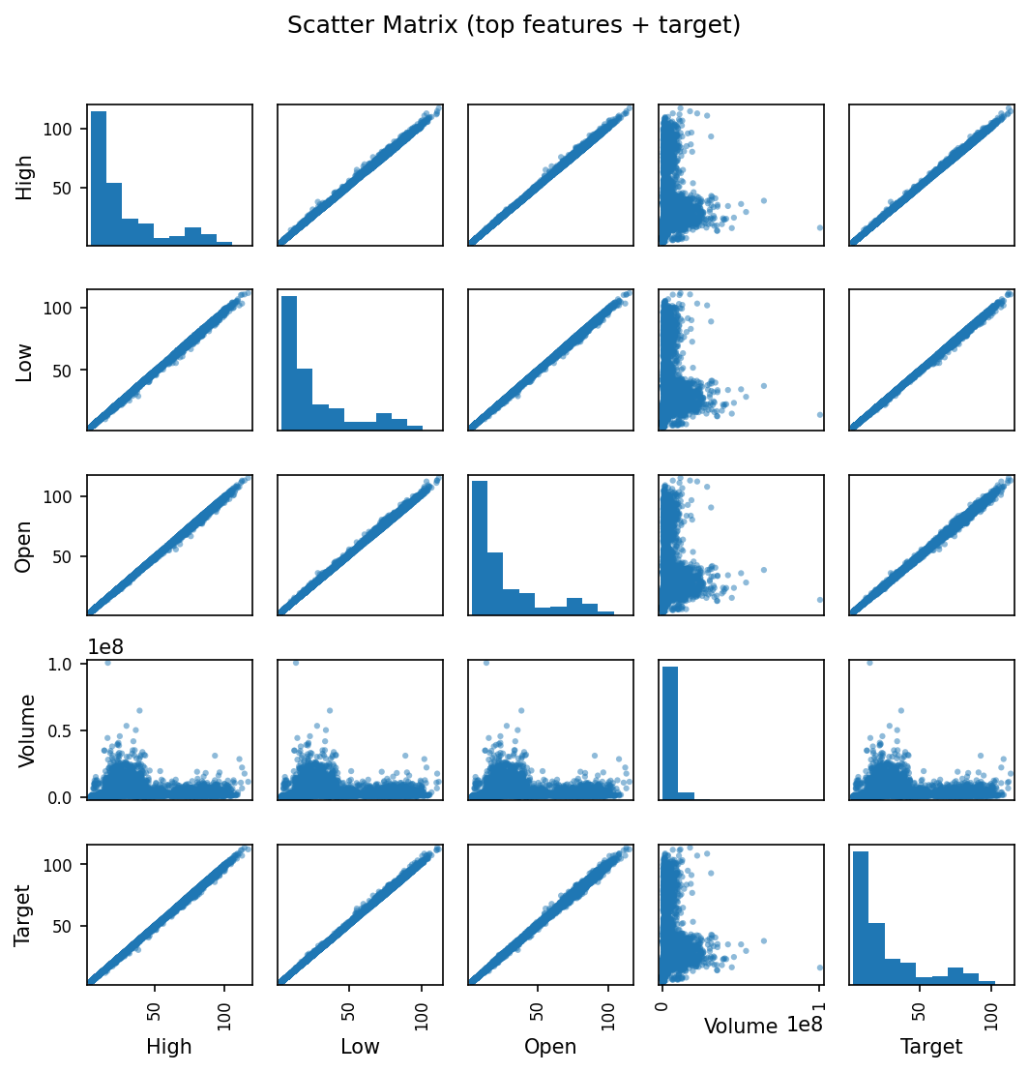

Обучаемость модели
Кривая обучения (RandomForest, TimeSeriesSplit) иллюстрирует влияние объёма обучающей выборки на качество.

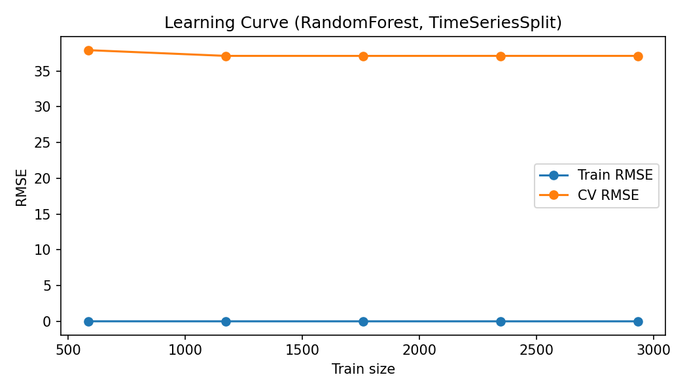

Экспорт предсказаний

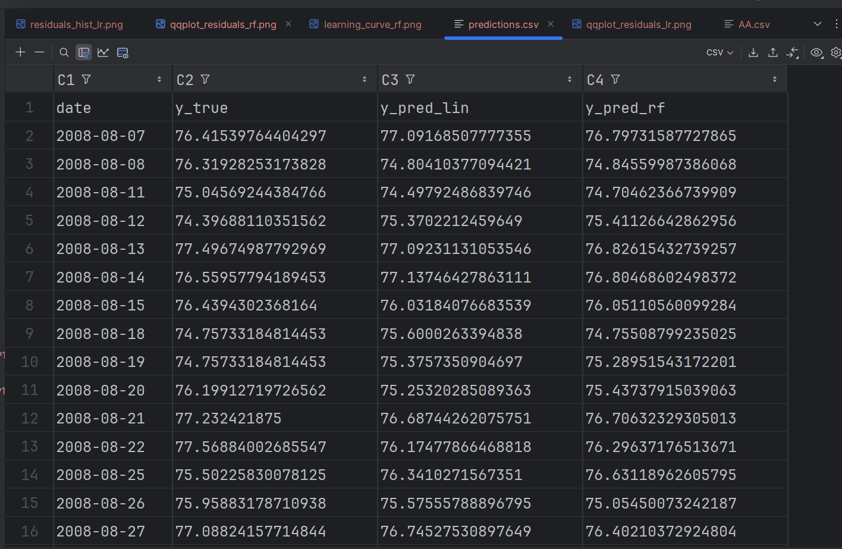

Код Программы
import os
from datetime import datetime
import matplotlib.pyplot as plt
import numpy as np
import pandas as pd
from sklearn.ensemble import RandomForestRegressor
from sklearn.linear_model import LinearRegression
from sklearn.metrics import mean_squared_error, r2_score
from sklearn.model_selection import TimeSeriesSplit, GridSearchCV
from sklearn.pipeline import Pipeline
from sklearn.preprocessing import StandardScaler
def show_df(name, df, head_n = None):
try:
from caas_jupyter_tools import display_dataframe_to_user
display_dataframe_to_user(name, df.head(head_n) if head_n else df)
except Exception:
print(f"\n=== {name} ===")
print((df.head(head_n) if head_n else df).to_string())
def coerce_numeric_cols(df, cols):
out = df.copy()
for c in cols:
if c not in out.columns:
continue
if pd.api.types.is_numeric_dtype(out[c]):
continue
s = out[c].astype(str)
s = s.str.replace("\u00A0", "", regex=False).str.replace(" ", "", regex=False)
s = s.str.replace(",", ".", regex=False)
s = s.str.replace(r"[^0-9\.\-eE]", "", regex=True)
num = pd.to_numeric(s, errors="coerce")
if num.notna().mean() >= 0.7:
out[c] = num
return out
csv_path = "AA.csv"
df = pd.read_csv(csv_path)
if 'Date' in df.columns:
df['Date'] = pd.to_datetime(df['Date'], errors='coerce')
priority_numeric = ['Open', 'High', 'Low', 'Close', 'Adj Close', 'Volume']
df = coerce_numeric_cols(df, [c for c in priority_numeric if c in df.columns])
head_df = df.head(10)
tail_df = df.tail(10)
show_df("Первые 10 строк датасета", head_df, head_n=None)
show_df("Последние 10 строк датасета", tail_df, head_n=None)
shape_info = df.shape
columns = df.columns.tolist()
nans_per_col = df.isna().sum()
overview_path = os.path.abspath("dataset_overview.txt")
with open(overview_path, "w", encoding="utf-8") as f:
f.write("Размерность датасета: {}\n".format(shape_info))
f.write("Столбцы: {}\n".format(columns))
f.write("\nКоличество пропусков по столбцам:\n{}\n".format(nans_per_col.to_string()))
if 'Date' in df.columns:
f.write("\nДиапазон дат: {} — {}\n".format(df['Date'].min(), df['Date'].max()))
print(f"Обзор сохранён: {overview_path}")
target_col = 'Close' if 'Close' in df.columns else None
if target_col is None:
raise ValueError("Не найден столбец 'Close' для целевой переменной.")
cols_to_drop = []
if 'Adj Close' in df.columns and target_col != 'Adj Close':
cols_to_drop.append('Adj Close')
date_series = df['Date'] if 'Date' in df.columns else None
df_clean = df.drop(columns=cols_to_drop)
num_cols_all = df_clean.columns[df_clean.columns.isin(columns)].tolist()
df_clean = coerce_numeric_cols(df_clean, [c for c in df_clean.columns if c != 'Date'])
num_cols = df_clean.select_dtypes(include=[np.number]).columns.tolist()
for c in num_cols:
median_val = df_clean[c].median()
df_clean[c] = df_clean[c].fillna(median_val)
if date_series is not None and date_series.isna().any():
date_series = date_series.fillna(method='ffill')
if target_col and target_col in df_clean.columns and date_series is not None and pd.api.types.is_numeric_dtype(df_clean[target_col]):
plt.figure(figsize=(10,4))
plt.plot(date_series, df_clean[target_col])
plt.title("Изменение цены закрытия во времени")
plt.xlabel("Дата")
plt.ylabel("Close")
plt.tight_layout()
plt.show()
if target_col and target_col in df_clean.columns and pd.api.types.is_numeric_dtype(df_clean[target_col]):
plt.figure(figsize=(6,4))
plt.hist(df_clean[target_col].dropna(), bins=50)
plt.title("Распределение цены закрытия (Close)")
plt.xlabel("Close")
plt.ylabel("Частота")
plt.tight_layout()
plt.show()
num_for_corr = df_clean.select_dtypes(include=[np.number])
if num_for_corr.shape[1] >= 2:
plt.figure(figsize=(7,6))
corr = num_for_corr.corr()
im = plt.imshow(corr.values, aspect='auto')
plt.colorbar(im, fraction=0.046, pad=0.04)
plt.xticks(range(len(corr.columns)), corr.columns, rotation=90)
plt.yticks(range(len(corr.columns)), corr.columns)
plt.title("Корреляционная матрица признаков")
plt.tight_layout()
plt.show()
if target_col is None or not pd.api.types.is_numeric_dtype(df_clean[target_col]):
raise ValueError("Целевой столбец 'Close' не числовой — обучение невозможно.")
feature_cols = [c for c in df_clean.select_dtypes(include=[np.number]).columns if c != target_col]
if not feature_cols:
raise ValueError("Нет числовых признаков для обучения.")
X_all = df_clean[feature_cols].copy()
y_all = df_clean[target_col].copy()
if date_series is not None:
order = np.argsort(pd.Series(date_series).values)
else:
order = np.arange(len(df_clean))
X_all = X_all.iloc[order].reset_index(drop=True)
y_all = y_all.iloc[order].reset_index(drop=True)
dates_sorted = None
if date_series is not None:
dates_sorted = pd.Series(date_series).iloc[order].reset_index(drop=True)
split_idx = int(len(X_all) * 0.8)
X_train, X_test = X_all.iloc[:split_idx], X_all.iloc[split_idx:]
y_train, y_test = y_all.iloc[:split_idx], y_all.iloc[split_idx:]
if dates_sorted is not None:
dates_train, dates_test = dates_sorted.iloc[:split_idx], dates_sorted.iloc[split_idx:]
else:
dates_train, dates_test = None, None
linreg_pipeline = Pipeline([
("scaler", StandardScaler()),
("model", LinearRegression())
])
linreg_pipeline.fit(X_train, y_train)
y_pred_lin = linreg_pipeline.predict(X_test)
rf = RandomForestRegressor(random_state=42, n_estimators=150, n_jobs=1)
rf.fit(X_train, y_train)
y_pred_rf = rf.predict(X_test)
def evaluate(y_true, y_pred):
mse = mean_squared_error(y_true, y_pred)
rmse = np.sqrt(mse)
r2 = r2_score(y_true, y_pred)
return rmse, r2
rmse_lin, r2_lin = evaluate(y_test, y_pred_lin)
rmse_rf, r2_rf = evaluate(y_test, y_pred_rf)
print("Оценка качества (тест):")
print(f"Линейная регрессия: RMSE={rmse_lin:.4f}, R2={r2_lin:.4f}")
print(f"Случайный лес: RMSE={rmse_rf:.4f}, R2={r2_rf:.4f}")
plt.figure(figsize=(6,6))
plt.scatter(y_test, y_pred_lin, s=10, label="LinearRegression")
plt.scatter(y_test, y_pred_rf, s=10, label="RandomForest")
min_v = min(y_test.min(), y_pred_lin.min(), y_pred_rf.min())
max_v = max(y_test.max(), y_pred_lin.max(), y_pred_rf.max())
plt.plot([min_v, max_v], [min_v, max_v])
plt.xlabel("Фактические значения Close")
plt.ylabel("Предсказанные значения Close")
plt.title("Фактические vs предсказанные")
plt.legend()
plt.tight_layout()
plt.show()
if dates_test is not None:
plt.figure(figsize=(10,4))
plt.plot(dates_test, y_test.values, label="Факт")
plt.plot(dates_test, y_pred_lin, label="LinearRegression")
plt.plot(dates_test, y_pred_rf, label="RandomForest")
plt.title("Предсказания на тесте во времени")
plt.xlabel("Дата")
plt.ylabel("Close")
plt.legend()
plt.tight_layout()
plt.show()
lin_coef = linreg_pipeline.named_steps['model'].coef_
lin_features = feature_cols
coef_df = pd.DataFrame({"feature": lin_features, "coef": lin_coef}).sort_values("coef", key=abs, ascending=False)
show_df("Коэффициенты линейной регрессии", coef_df)
rf_imp = pd.DataFrame({"feature": feature_cols, "importance": rf.feature_importances_}).sort_values("importance", ascending=False)
show_df("Важности признаков (RandomForest)", rf_imp)
param_grid = {
"n_estimators": [100, 150, 200],
"max_depth": [None, 8, 16],
"min_samples_leaf": [1, 2]
}
tscv = TimeSeriesSplit(n_splits=3)
gbrf = GridSearchCV(
RandomForestRegressor(random_state=42),
param_grid=param_grid,
cv=tscv,
scoring="neg_mean_squared_error",
n_jobs=1
)
gbrf.fit(X_train, y_train)
best_rf = gbrf.best_estimator_
y_pred_best = best_rf.predict(X_test)
rmse_best, r2_best = evaluate(y_test, y_pred_best)
print("\nЛучшие гиперпараметры RF:", gbrf.best_params_)
print(f"После настройки: RMSE={rmse_best:.4f}, R2={r2_best:.4f}")
report_path = os.path.abspath("ml_stock_report.txt")
with open(report_path, "w", encoding="utf-8") as f:
f.write("Задание: Предсказание цен на акции\n")
f.write(f"Дата выполнения: {datetime.now()}\n\n")
f.write(f"Размерность датасета: {shape_info}\n")
f.write(f"Столбцы: {columns}\n\n")
if 'Date' in df.columns:
f.write(f"Диапазон дат: {df['Date'].min()} — {df['Date'].max()}\n\n")
f.write("Оценка качества (тест):\n")
f.write(f"- Линейная регрессия: RMSE={rmse_lin:.4f}, R2={r2_lin:.4f}\n")
f.write(f"- Случайный лес: RMSE={rmse_rf:.4f}, R2={r2_rf:.4f}\n")
f.write("Лучшие гиперпараметры RandomForest: {}\n".format(gbrf.best_params_))
f.write(f"После настройки: RMSE={rmse_best:.4f}, R2={r2_best:.4f}\n\n")
f.write("Примечание: Целевая переменная — Close. Признаки масштабированы для линейной регрессии. "
"Разделение выполнено по времени (80/20). Пропуски в числовых столбцах заполнены медианой.\n")
print(f"Отчёт сохранён: {report_path}")
import pathlib
from sklearn.model_selection import learning_curve
PLOTS_DIR = pathlib.Path("plots")
PLOTS_DIR.mkdir(exist_ok=True)
res_lin = y_test - y_pred_lin
res_rf = y_test - y_pred_rf
plt.figure(figsize=(6,5))
plt.scatter(y_pred_lin, res_lin, s=10, label="LR")
plt.axhline(0, linestyle="--")
plt.xlabel("Fitted (LR)"); plt.ylabel("Residuals")
plt.title("Residuals vs Fitted (LinearRegression)")
plt.tight_layout()
plt.savefig(PLOTS_DIR / "residuals_vs_fitted_lr.png", dpi=150)
plt.show()
plt.figure(figsize=(6,5))
plt.scatter(y_pred_rf, res_rf, s=10, label="RF")
plt.axhline(0, linestyle="--")
plt.xlabel("Fitted (RF)"); plt.ylabel("Residuals")
plt.title("Residuals vs Fitted (RandomForest)")
plt.tight_layout()
plt.savefig(PLOTS_DIR / "residuals_vs_fitted_rf.png", dpi=150)
plt.show()
plt.figure(figsize=(6,4))
plt.hist(res_lin, bins=50)
plt.title("Residuals distribution (LR)")
plt.tight_layout()
plt.savefig(PLOTS_DIR / "residuals_hist_lr.png", dpi=150)
plt.show()
plt.figure(figsize=(6,4))
plt.hist(res_rf, bins=50)
plt.title("Residuals distribution (RF)")
plt.tight_layout()
plt.savefig(PLOTS_DIR / "residuals_hist_rf.png", dpi=150)
plt.show()
try:
from scipy import stats
plt.figure(figsize=(5,5))
stats.probplot(res_lin, dist="norm", plot=plt)
plt.title("QQ-plot residuals (LR)")
plt.tight_layout()
plt.savefig(PLOTS_DIR / "qqplot_residuals_lr.png", dpi=150)
plt.show()
plt.figure(figsize=(5,5))
stats.probplot(res_rf, dist="norm", plot=plt)
plt.title("QQ-plot residuals (RF)")
plt.tight_layout()
plt.savefig(PLOTS_DIR / "qqplot_residuals_rf.png", dpi=150)
plt.show()
except Exception:
print("SciPy недоступен — QQ-plot пропущен.")
importances_df = pd.DataFrame({
"feature": feature_cols,
"importance": rf.feature_importances_
}).sort_values("importance", ascending=False)
plt.figure(figsize=(max(8, min(14, 0.35*len(importances_df))), 5))
plt.bar(range(len(importances_df)), importances_df["importance"])
plt.xticks(range(len(importances_df)), importances_df["feature"], rotation=90)
plt.title("Feature importances (RandomForest)")
plt.tight_layout()
plt.savefig(PLOTS_DIR / "rf_feature_importances.png", dpi=150)
plt.show()
TOP_N = min(6, len(importances_df))
top_feats = importances_df["feature"].iloc[:TOP_N].tolist()
try:
from pandas.plotting import scatter_matrix
sm_df = pd.concat([X_all[top_feats], y_all.rename("Target")], axis=1)
axes = scatter_matrix(sm_df, figsize=(1.8*TOP_N, 1.8*TOP_N), diagonal='hist')
plt.suptitle("Scatter Matrix (top features + target)", y=1.02)
plt.tight_layout()
plt.savefig(PLOTS_DIR / "scatter_matrix_top_features.png", dpi=150, bbox_inches="tight")
plt.show()
except Exception as e:
print(f"Scatter matrix не построен: {e}")
tscv_lc = TimeSeriesSplit(n_splits=3)
train_sizes, train_scores, val_scores = learning_curve(
estimator=RandomForestRegressor(random_state=42, n_estimators=150, n_jobs=1),
X=X_train, y=y_train,
cv=tscv_lc,
train_sizes=np.linspace(0.2, 1.0, 5),
scoring="neg_mean_squared_error",
n_jobs=1
)
train_rmse = np.sqrt(-train_scores.mean(axis=1))
val_rmse = np.sqrt(-val_scores.mean(axis=1))
plt.figure(figsize=(7,4))
plt.plot(train_sizes, train_rmse, marker="o", label="Train RMSE")
plt.plot(train_sizes, val_rmse, marker="o", label="CV RMSE")
plt.xlabel("Train size"); plt.ylabel("RMSE")
plt.title("Learning Curve (RandomForest, TimeSeriesSplit)")
plt.legend()
plt.tight_layout()
plt.savefig(PLOTS_DIR / "learning_curve_rf.png", dpi=150)
plt.show()
preds_df = pd.DataFrame({
"index": y_test.index,
"y_true": y_test.values,
"y_pred_lin": y_pred_lin,
"y_pred_rf": y_pred_rf
})
if dates_sorted is not None:
preds_df["date"] = dates_test.values
preds_df = preds_df[["date","y_true","y_pred_lin","y_pred_rf"]] if "date" in preds_df.columns else preds_df[["index","y_true","y_pred_lin","y_pred_rf"]]
preds_csv = os.path.abspath("predictions.csv")
preds_df.to_csv(preds_csv, index=False)
print(f"Предсказания сохранены: {preds_csv}")
print(f"Папка с графиками: {PLOTS_DIR.resolve()}")

